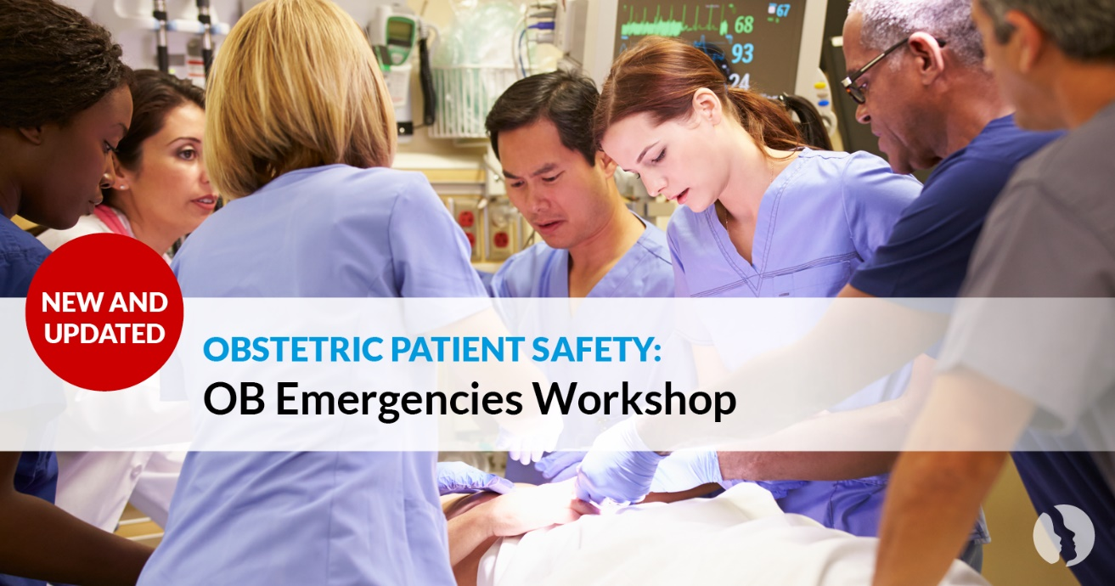
Obstetric Patient Safety: OB Emergencies Workshop
Despite efforts from many collaborating agencies and
professional organizations, the maternal mortality rate in
the United States continues to remain high. The new
Obstetric Patient Safety (OPS): Obstetric Emergencies
Workshop is designed to help nurses and providers
identify, assess, and manage the care for women with
specific obstetric emergencies such as hypertensive
disorders of pregnancy, postpartum hemorrhage, and maternal sepsis. Nurses and providers working in the following departments: perinatal, emergency, medical-surgical, ICU, and critical access will find this course essential to caring for women presenting with obstetric emergencies.

Simulation Learning
The engaging, live, hands-on Workshop provides for practice through simulation for nurses and providers to reduce the risk of maternal injury and death.

Learning Outcomes:
- Demonstrate effective management for pregnant or postpartum women who present with hypertensive disorders of pregnancy. ​
- Demonstrate effective management for women who have excessive bleeding after giving birth.​
- Demonstrate effective management for maternal sepsis.​
- Role-play with a multidisciplinary team using simulation-based cognitive, behavioral, and technical learning strategies to practice management of postpartum hemorrhage.

Workshop Date: ___________________________ Workshop Time: ____________________________

Location: ___________________________________________________________________________

Cost: ____________________________________ Registration/Payment Deadline: ________________

Submit Registration To: ________________________________________________________________

The course content also meets the Joint Commission requirements for PC 06.01.01 Reduce the likelihood of harm related to maternal hemorrhage and PC.06.03.01 Reduce the likelihood of harm related to maternal severe hypertension/preeclampsia.

